Order Of Service

Singing: Psalm 62—CW page 88

Reading: Psalm 46

Opening Hymn: TLH 657

Reading: Galatians 2:1-10

Request Hymn: CW Supplement 702

Reading: Mark 8:31-38

Sermon Hymn: TLH 457

Sermon Text: Luke 18:15-17

Little Children

Prayer

The Apostles’ Creed, TLH page 12

Holy Communion

The Lord's Prayer

The Blessing

Closing Hymn: TLH 648

************

Bible Study: Lambs: Gyp—Only One Woof
Sheep: Deuteronomy 1:9-18
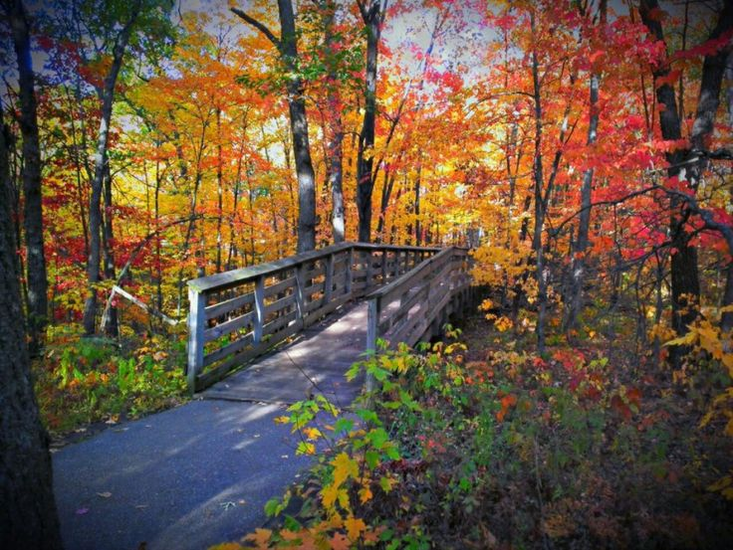

Fall In Duluth

Water
Of
Life

20 November 2022

W A T E R O F L I F E

Independent Christian Church—Conservative Lutheran Doctrine

Worship Service: 9:30 a.m.

Larry Cooper, Pastor E-Mail address:
111 N. Ridge Road lcooper@wateroflife.cc
Coon Valley, WI 54623 Web Site:
www.wateroflife.cc

* * * * * * * * * * * * * * * * * * * * * * * * * * *

Sermon Text: Luke 18:15-17

Little Children

* * * * * * * * * * * * * * * * * * * * * * * * * * *

15 And they brought unto him also infants, that he would touch them: but when his disciples saw it, they rebuked them.
16 But Jesus called them unto him, and said, Suffer little children to come unto me, and forbid them not: for of such is the kingdom of God.
17 Verily I say unto you, Whosoever shall not receive the kingdom of God as a little child shall in no wise enter therein.

